CSA Connector Updates for November 2024

You will now be able to receive the Multi Factor Authentication (MFA) code by email. When you sign in, you will see this new option listed.
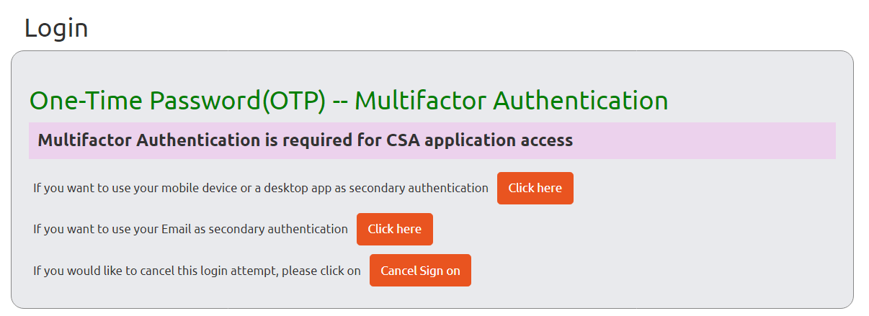
You will be brought to this screen which will list the email address the code was sent to. Once you get the code, enter it and select “Verify OTP.” If you don’t receive the code after a few minutes, select “Resend OTP.” If you want to cancel your login attempt, select “Cancel Sign On.”
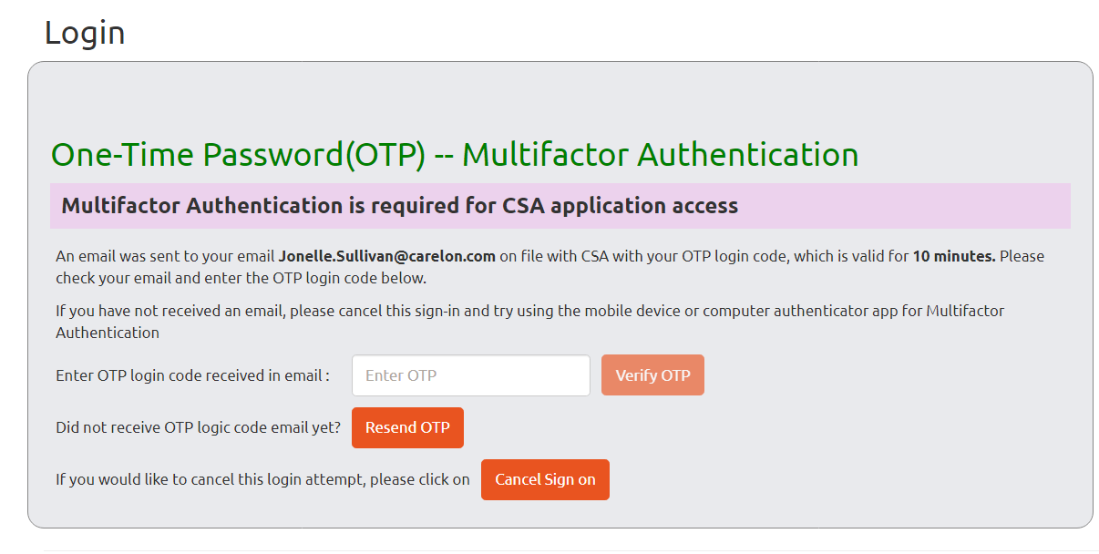
Once you enter the code, you will be brought to the login page and can proceed as usual.
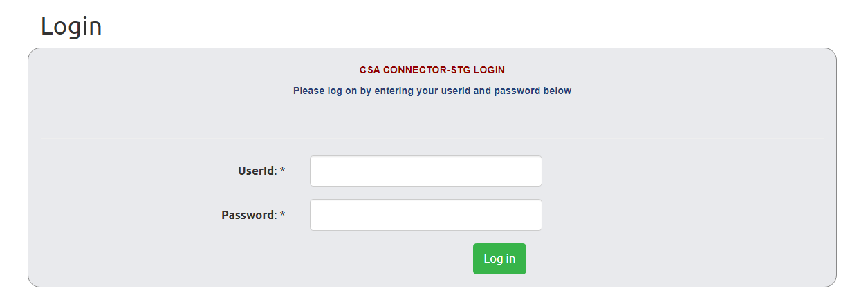
CSAs can now create and update CSA Connector Accounts for staff members at their CSAs. When you sign in you will see a new option at the top “Admin.”

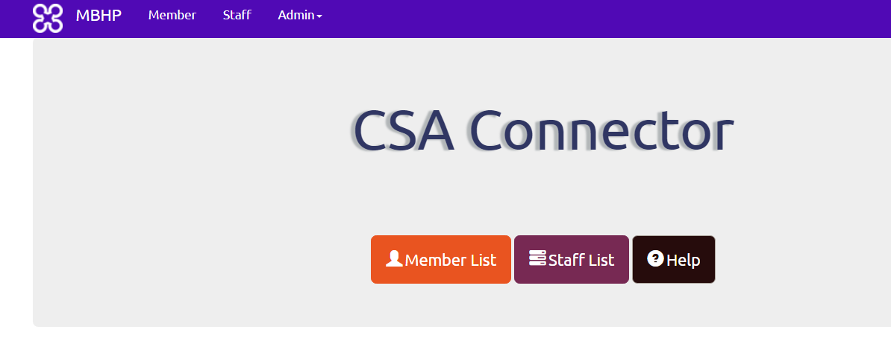
To create a new account, select “Register.”

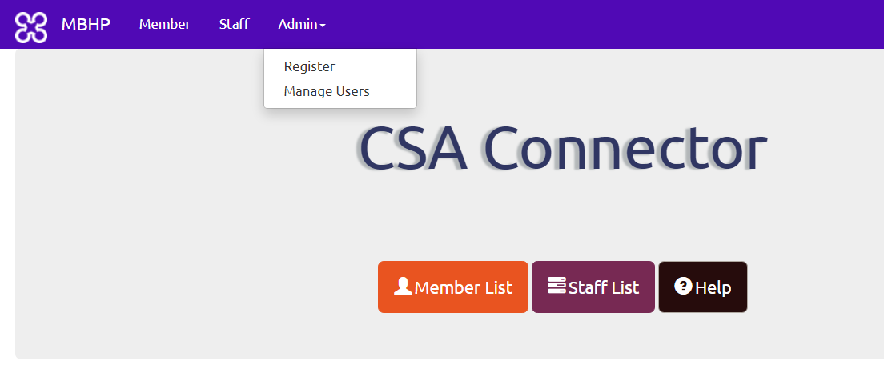
Enter all the required information.
- The CSA name will automatically populate, and you won’t be able to change that.
- The username should be something unique that you create. For staff who will need multiple accounts to access more than one CSA, the username must be different for each account.
- Once you enter all the data select “Register.”
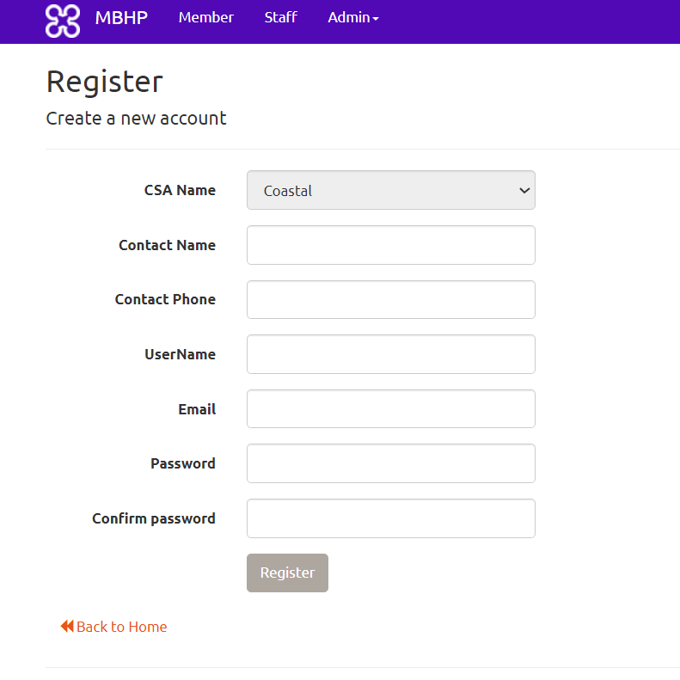
You will be brought to a screen that shows all the accounts linked to your CSA, and there will be a message on top that says “User created successfully.”
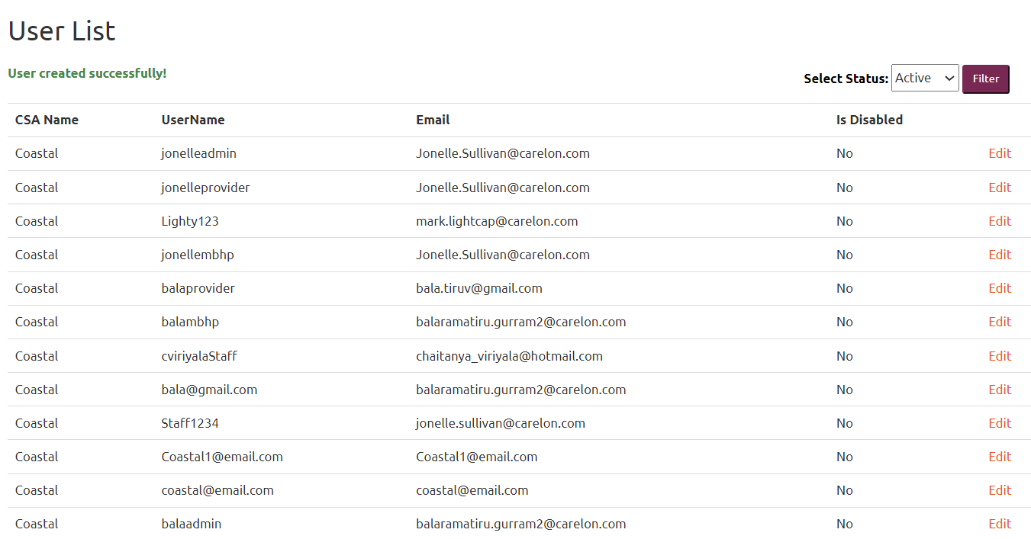

To update an existing account, select “Manage Users.”

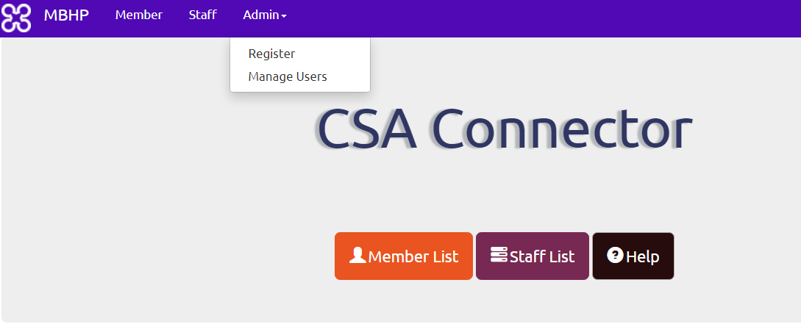

This will bring you to a screen that lists all the active users for your CSA Connector. Select “Edit” next to the staff member you need to update.
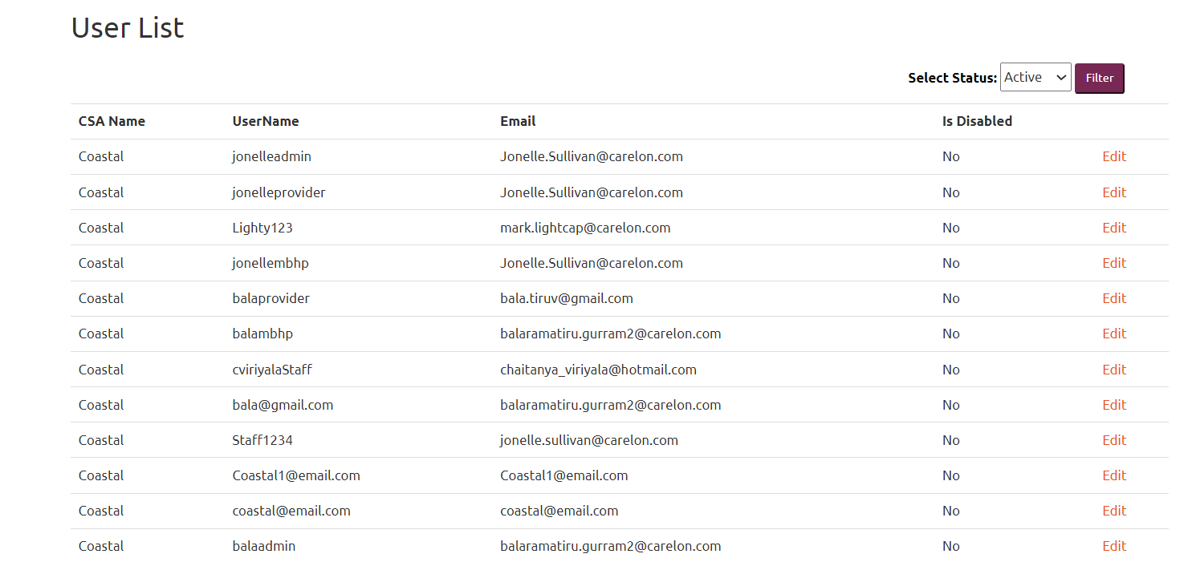

This will open their account; you can edit the three items in red.
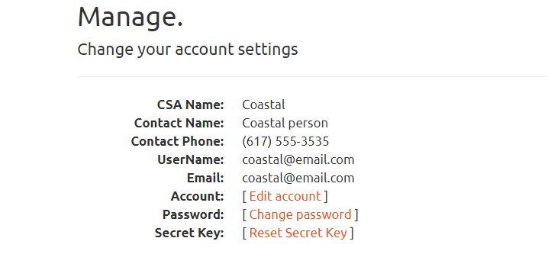
When a staff member leaves or no longer needs access to the Connector, you need to disable their account. Select “Edit account”; when the next screen opens, check the “Is Disabled” box and then select “Save.”
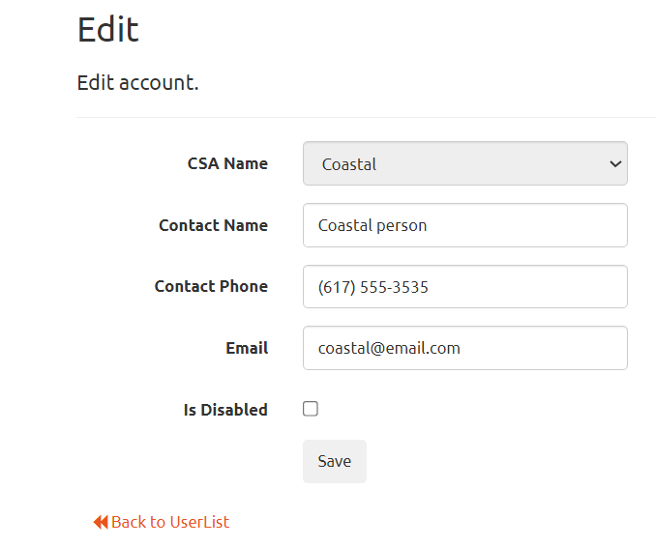
You will be brought back to the list of active users; that staff member will no longer show up, and there will be a message that your update was successful.
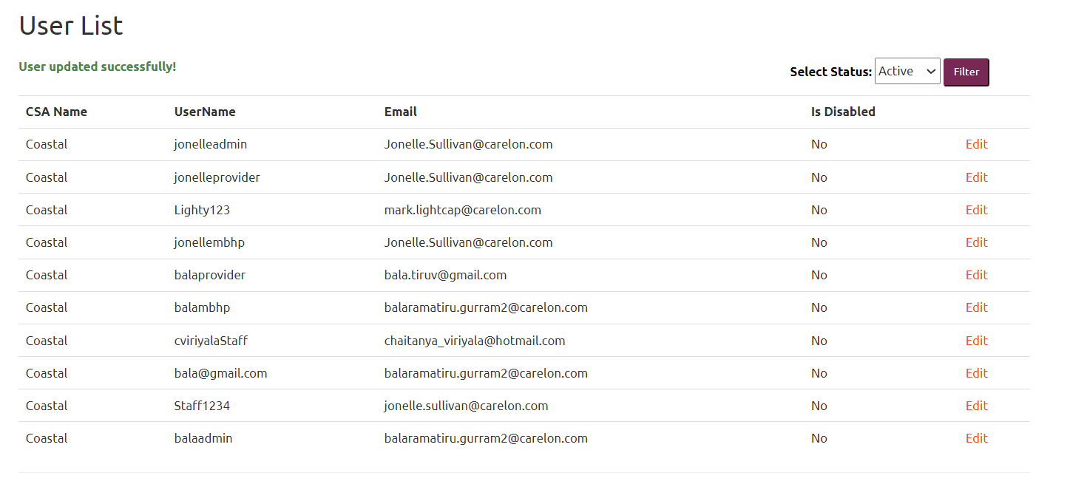

To see all users including ones you have disabled, chose “All” in the select status box and then select “Filter.”
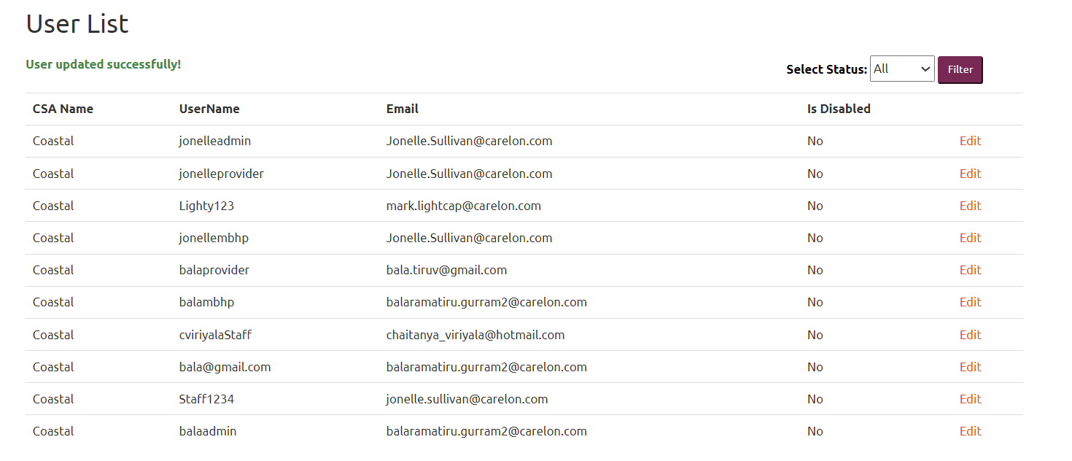
You will now see a screen with all the users who currently have an account or have a disabled account.
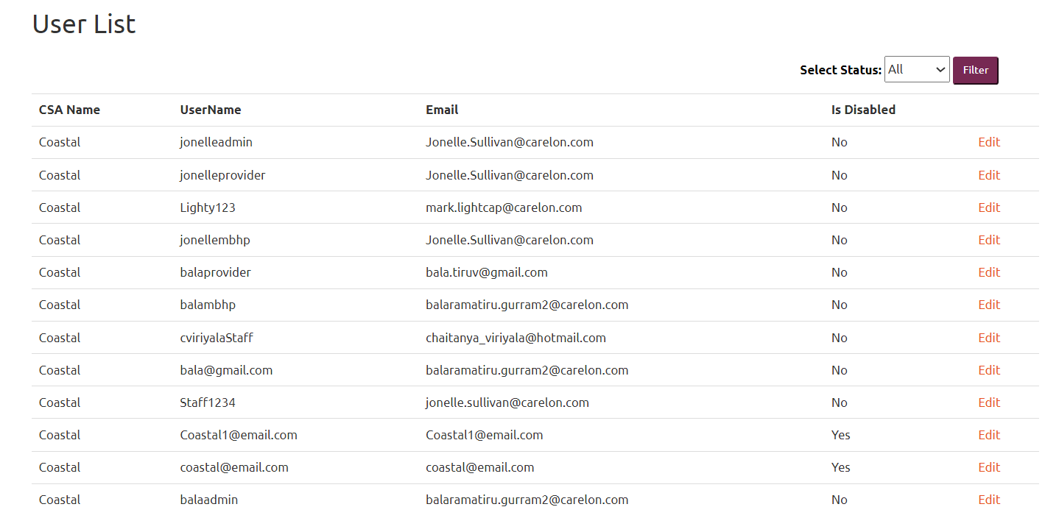

You can also update a user’s name, phone number, and/or email address in this section.
Add the new information, and then select “Save.” You will be brought back to the list of all the users linked to your CSA and will see a message that your update was successful.
If a user forgets their password, you can reset it for them in the manage users section.
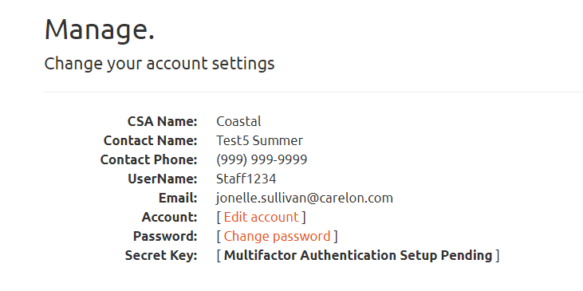

Once you enter a new password, select “Change password,” and you will be brought back to the page that shows all the users.
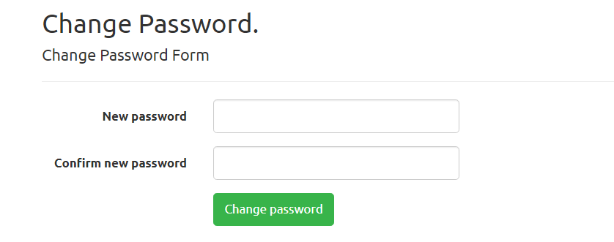

You will need to email the new password to the staff member.

For staff members who use an app on a mobile device or desktop for authentication and need to reset their MFA, they will need their secret key reset.
Once you select “Reset Secret Key” you will be brought to this screen:

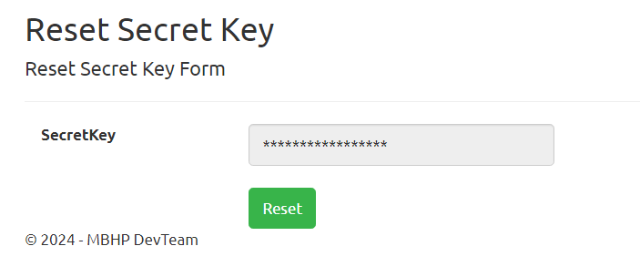

Select “Reset”: a pop-up box will ask you to confirm. If you want to reset, select “Confirm.”
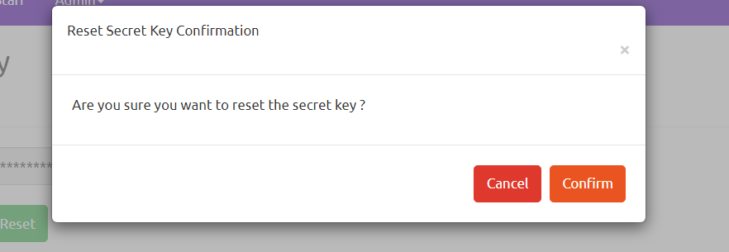

You will be brought back to the list of active users, and a message will appear that your update was successful.
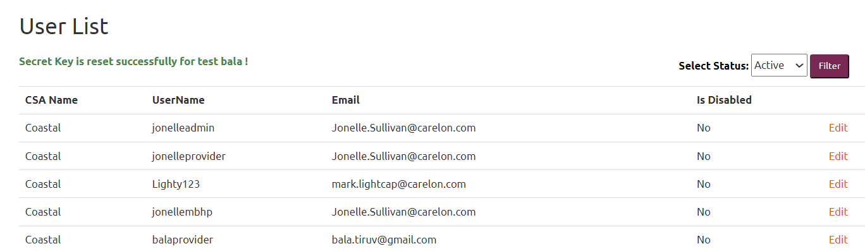

The staff member can now sign on and redo the MFA process.

If you have any technical issues with the CSA Connector, please contact
dl-bh-mbhpaccountsupport@carelon.com

